**YOUR MIND AT *REST?***

**The science behind mindfulness**

Workshop Tutorial - by Karina Hyland

**I. WHAT IS THIS WORKSHOP ABOUT**

Have you ever felt that is impossible to put your mind to rest? Have you found yourself immersed in mind wandering and completely forgotten how you got home? Do you sometimes come up with ideas or solve problems when looking out of the window of the train? Do you go over your whole day after going to bed or plan what will you be doing the next day? All of these experiences have a reason and a neural network dedicated to it. In this workshop you will be able to experience and understand the differences between a wandering mind and an attentive one.

The goal of this workshop is to engage the participants with a novel scientific finding, the discovery and description of the Default Mode Network. By a doing a rather simple activity, the participants will be able to experience two opposed mental states: attention and ‘rest’. After performing this exercise, the facilitator will explain the foundations of these states in order to make sense of the of the previous exercise.

**Learning objective:** Recognize the neural activity of the Default Mode Network by being aware that exists and how.

**Target audience:** Any adult or elder who has a some sensibility, curiosity or interest in how the mind works. Ability to read and write are required.

**Learning outcome:** The attendants will understand how their minds cycle through the attention and resting states and build the tools to gain a bit of control over their minds, to improve attention and techniques on how to rest the mind.

**Duration:**

10 minutes previous to the workshop set hour for preparation of materials, video and sound.

30 minutes for practical activities (part 1)

20 minutes for presentation (part 2)

**Technical requirements:** A room with table space for each participant facing a screen or projector to show slides and speakers.

**II. SCIENTIFIC FRAMEWORK**

Recent studies in cognitive neuroscience have discovered a complex neural network that activates when not performing a task. Every time the mind wanders and an inner conversation takes place, a series of brain regions work together to achieve some very important mental processes. These regions conform the default mode network (DMN), and its study has become critical for understanding how consciousness operates. This network can be described as mind-wandering, i.e. using past experiences to plan for the future, navigate social interactions, and maximize the utility of moments when we are not otherwise engaged by the external world [A]. Now we know that in order to understand how the brain works depends critically on the study of its intrinsic activity and how it gets us closer to the understanding of consciousness [B].

*Further readings can be found in the references at the end of this document.*

In this workshop I will present the main principles of this neural network and how it can help us on our daily lives. Everyone has experienced some kind of mind wandering, but not all of them are aware that it corresponds to a specific neural network.

**Steps**

The following [slides](https://docs.google.com/presentation/d/1Khtckfjlx6LK6XilseoJcxjdZryapKWfv4mc-BJqWBI/edit?usp=sharing) will serve as a guide through the entire workshop. Timing and presenter notes are included in the file. A detailed explanation of each step will be specified next, I will be using the slide number to reference each of them. Use slide 1 and 2 to introduce yourself and the workshop.

*You are welcome to make any changes in the slides, but make sure to make a copy of the original file to edit.*

**PART ONE**

Ask the participants to perform a quite difficult task that will force them to pay attention. After completing this, allow them to freely explore what they just did and allow time to continue the task without any specific directions.

1. Explain the first part of the activity. They will have to memorize the shadowed dots in a grid and then mark them on the paper provided **(slide 3, 4)**.
2. Present an image of a grid with random shadowed dots on it **(slide 5)**. Show it on a screen and make sure everybody can see without difficulties. Leave it there for a complete minute and then turn off the screen. Allow around 3 minutes or less to complete the dots. They will probably be quicker than that since memory fades in time. **(slide 6)**
3. Check if everybody finished marking their grids. If someone is taking more time than expected, let them know that they can keep on going without every dot.
4. Copy the dots onto the fabric using a felt-tip pen. (12 minutes should’ve passed up to this point) **(slide 7).**
5. Ask the participants to grab the needle provided and a piece of thread of their choice and thread the needle. Allow some time for those who do not have experience on doing this, it is ok if they have difficulties **(slide 8)**.
6. When everybody has the needle ready, they should start connecting the dots by stitching the fabric. The order or way they do it is up to each person. Suggest making a knot at the end of the thread to facilitate the stitching **(slide 9)**.
7. Play some instrumental music that encourages creativity [(suggested playlist)](https://open.spotify.com/user/karihigh/playlist/50Jxn51JSYmaeDbxiIcf5o?si=9qsg2vLjRwGugO_QuVVEdA).
8. After all dots are connected, they should continue stitching freely in the fabric. A good prompt is to ask them to complete whatever shape they came up with while connecting the dots. Suggest changing the color of the thread, assist if they need more, facilitate scissors if needed **(slide 10)**.
9. After 8 minutes of silent and free stitching, tell them to set their attention in every stitch they make. How does the needle perforates the fabric, feel the thread passing through the fibers, the amount of pressure, the speed, how they decide where to go next, the temperature of the needle versus the thread versus the fabric, etc. Take some time for the attentive exercise and then go back to silent stitching for another 6 minutes. (18 minutes should’ve passed, or 30 in total since the beginning of the session).

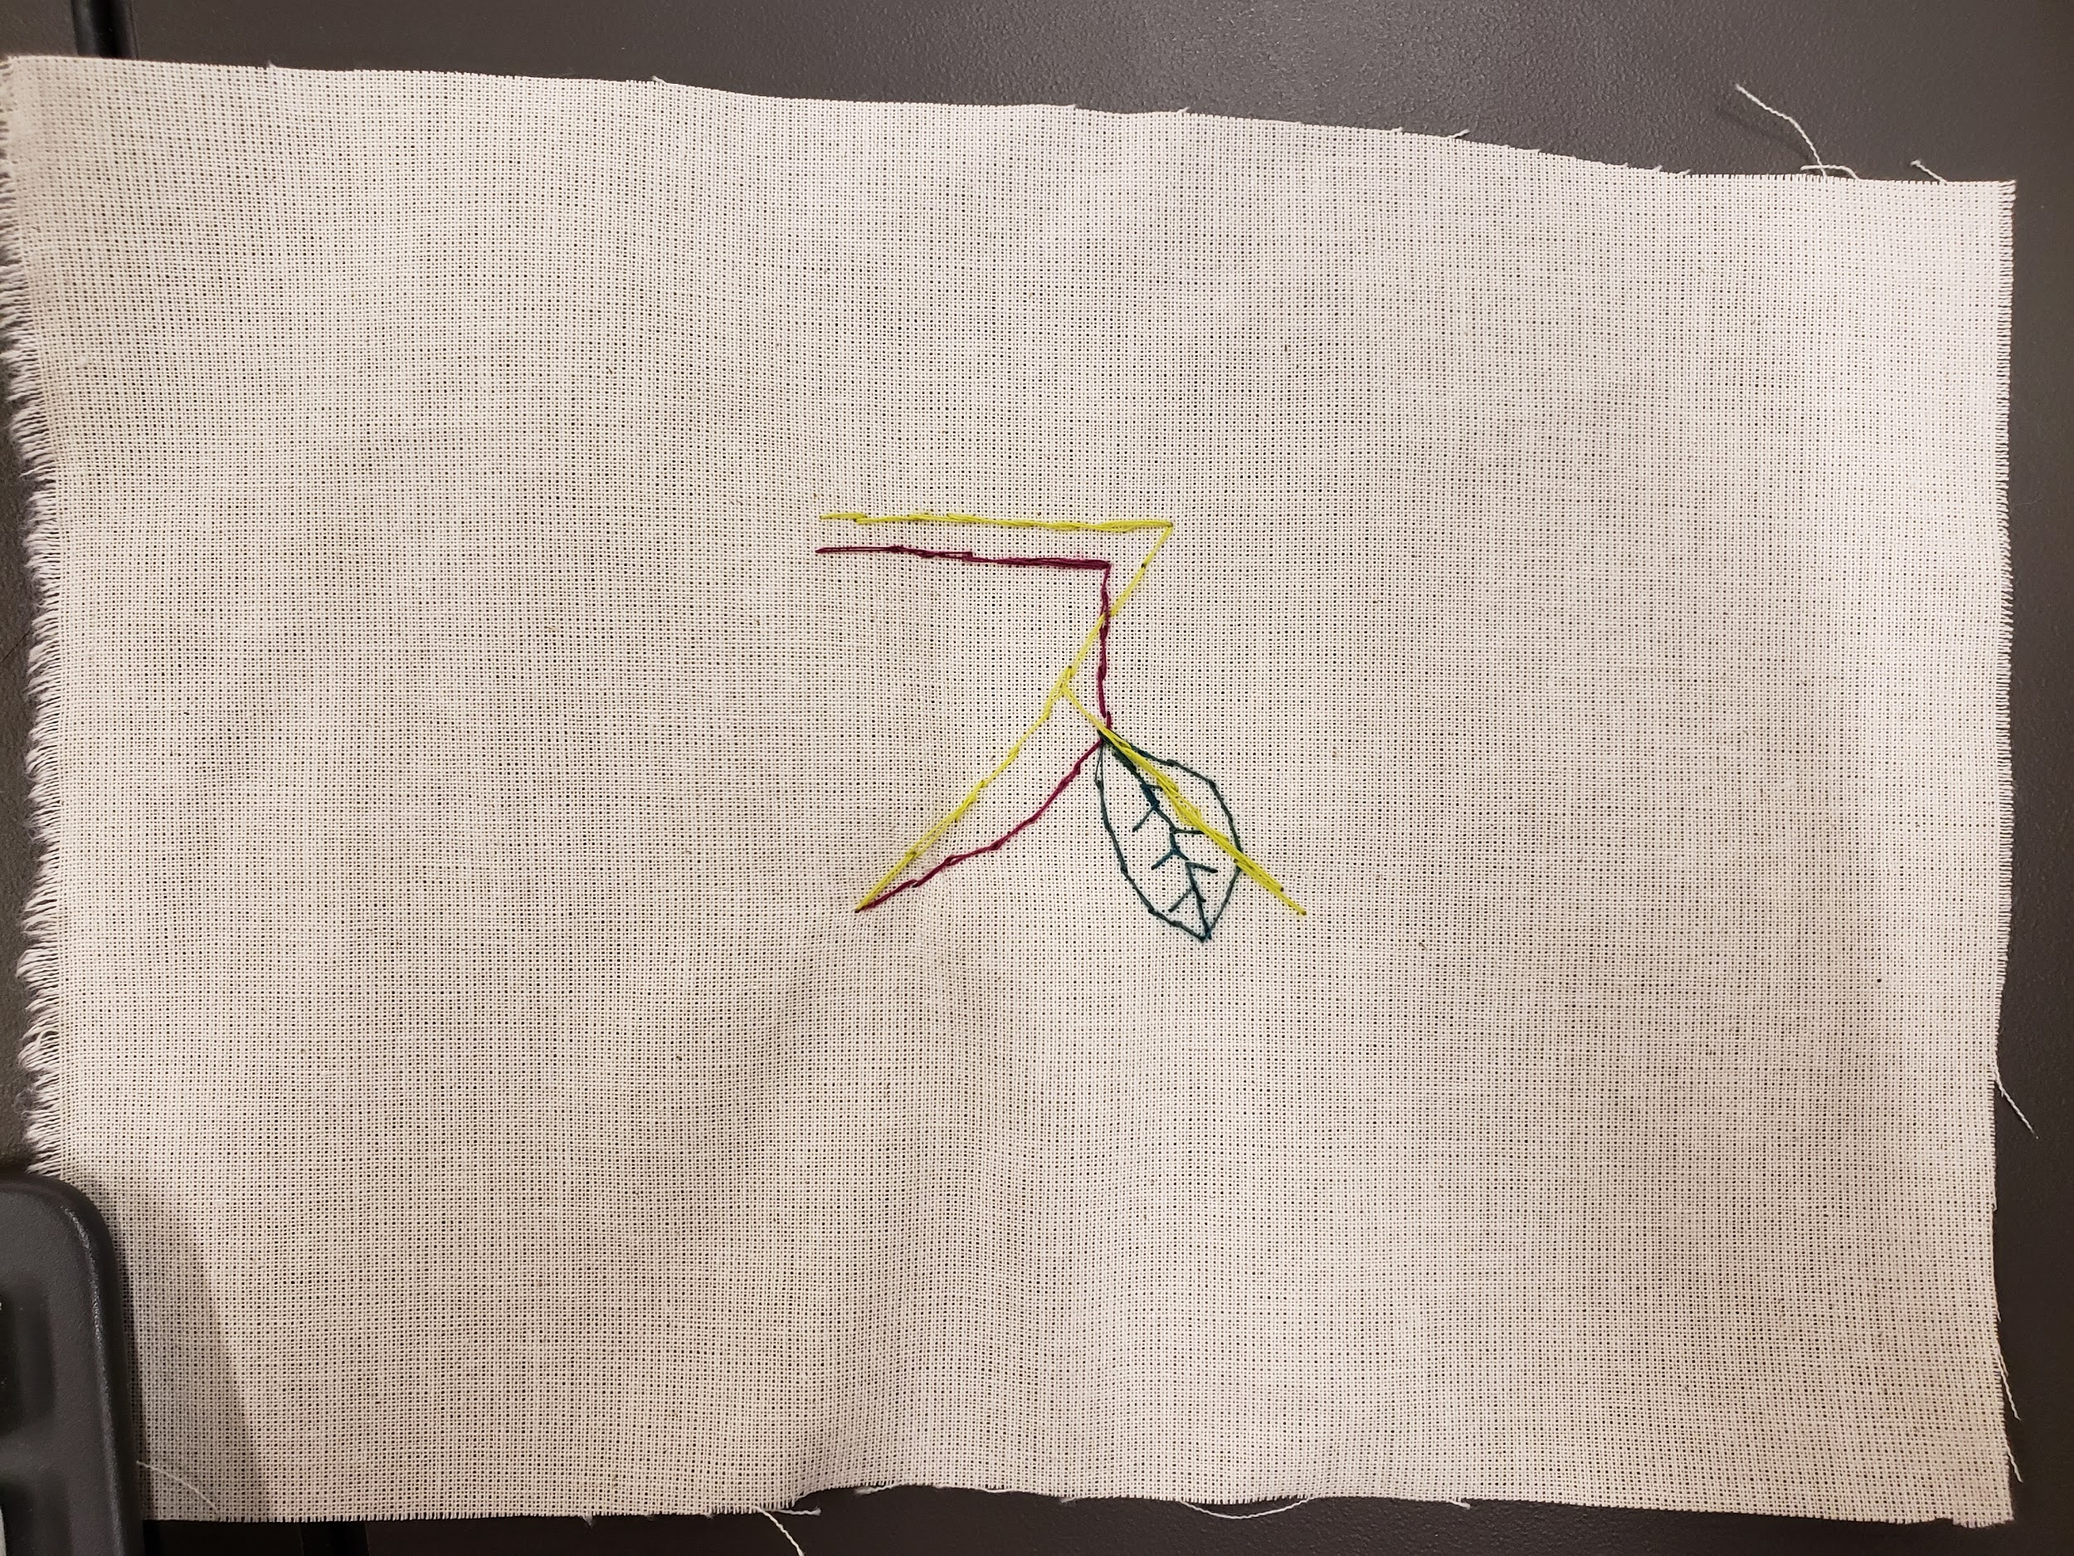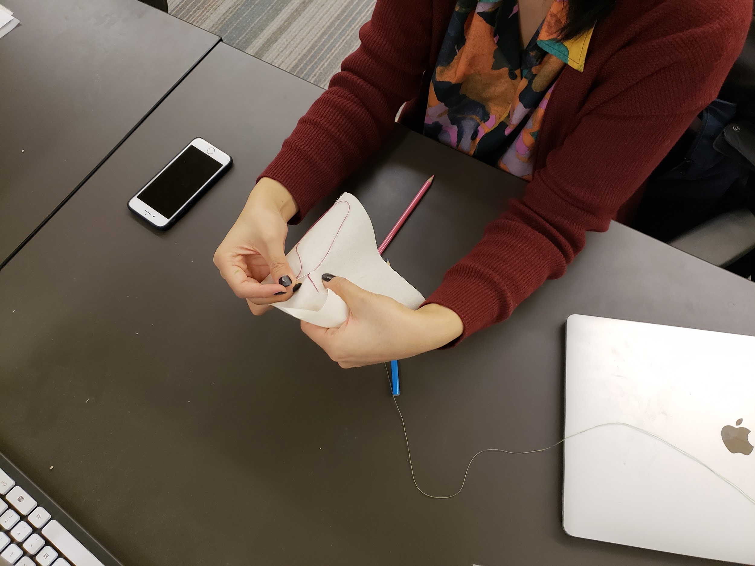

**PART TWO**

* Tell the participants to put aside their materials and pay attention to the screen. Review with them all the different activities they went through and list each of them in two categories: task-oriented or free expression **(slide 11, 12)**.
* Make them imagine that they were inside an MRI scanner through the workshop and that the image on the screen represents the brain’s energy consumption when performing the the activities **(slide 13)**.
* Ask which of the rows do they think refers to each of categories.
* It is likely that they will answer that the task-oriented activities correspond to the bottom row, which makes the whole point of the workshop **(slide 14, 15)**.
* When we are doing a mechanical activity (like stitching with no specific attention) the mind starts wandering in every direction. It does this by default, it is the intrinsic activity of the brain that is most active during the day. And even though we might think that we used more energy trying to memorize the dots on the screen.
* Explain the difference between the contents that the mind goes through when the default mode network is active. Go through the following to understand how did neuroscience got where we are now **(slide 16 - 25)**.
* Present how we can use this information on our daily lives and ways of actually resting the mind. Ask the personal experiences about this day-to-day situations asked in the abstract. Gather comments, questions and feedback about the theories presented and the way of experiencing both states of the mind.
* Show the videos linked on **slide 26** that exemplify the difference between the default and attention state.
* Discuss the questions proposed at the beginning and offer the answers according to the scientific framework **(slide 27 - 32)**.
* Use **slide 33 and 34** for general questions, comments and suggestions.

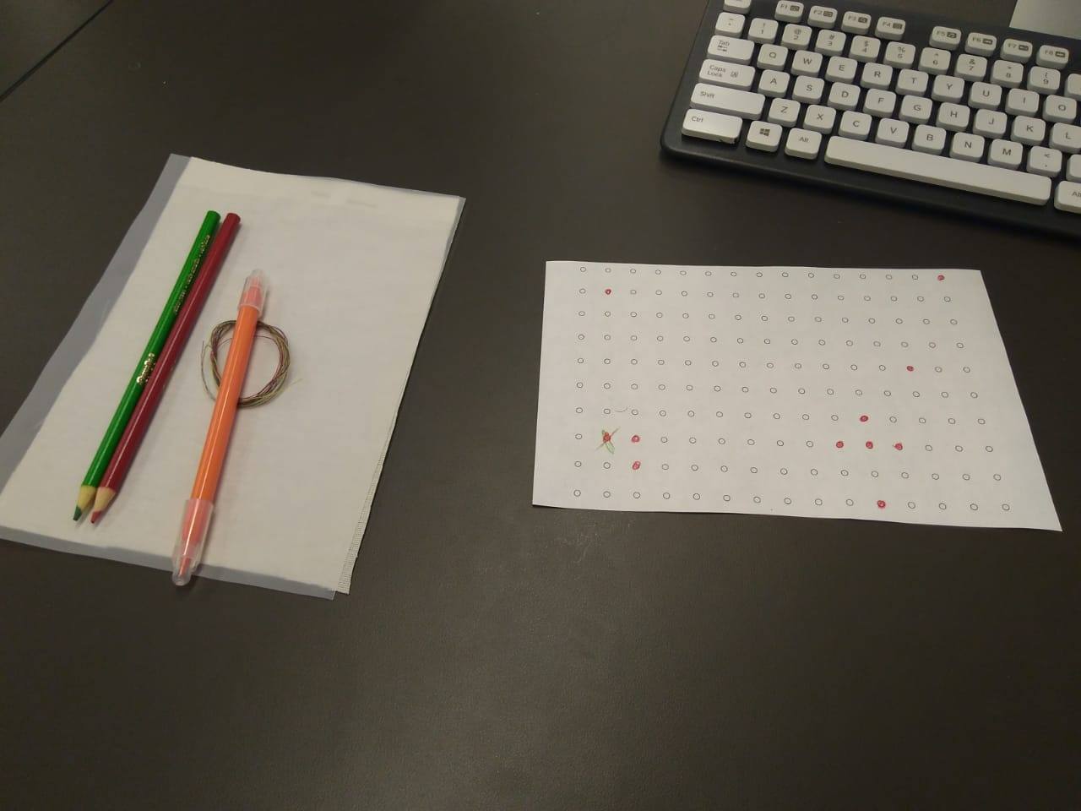

To do beforehand:

* Print the grid. Cut it in half using the dotted line.
* Cut pieces of fabric of the same size as the page (half letter)*
* Prepare 3 pieces of thread of 20’’ long from different colored*

*\*If these materials are available and can be reused, the size of the sheet and fabric can vary. It is recommended to keep a correlation between the grid sheet and the fabric, but it is not mandatory for the activity as long as the fabric covers completely the printed grid.*

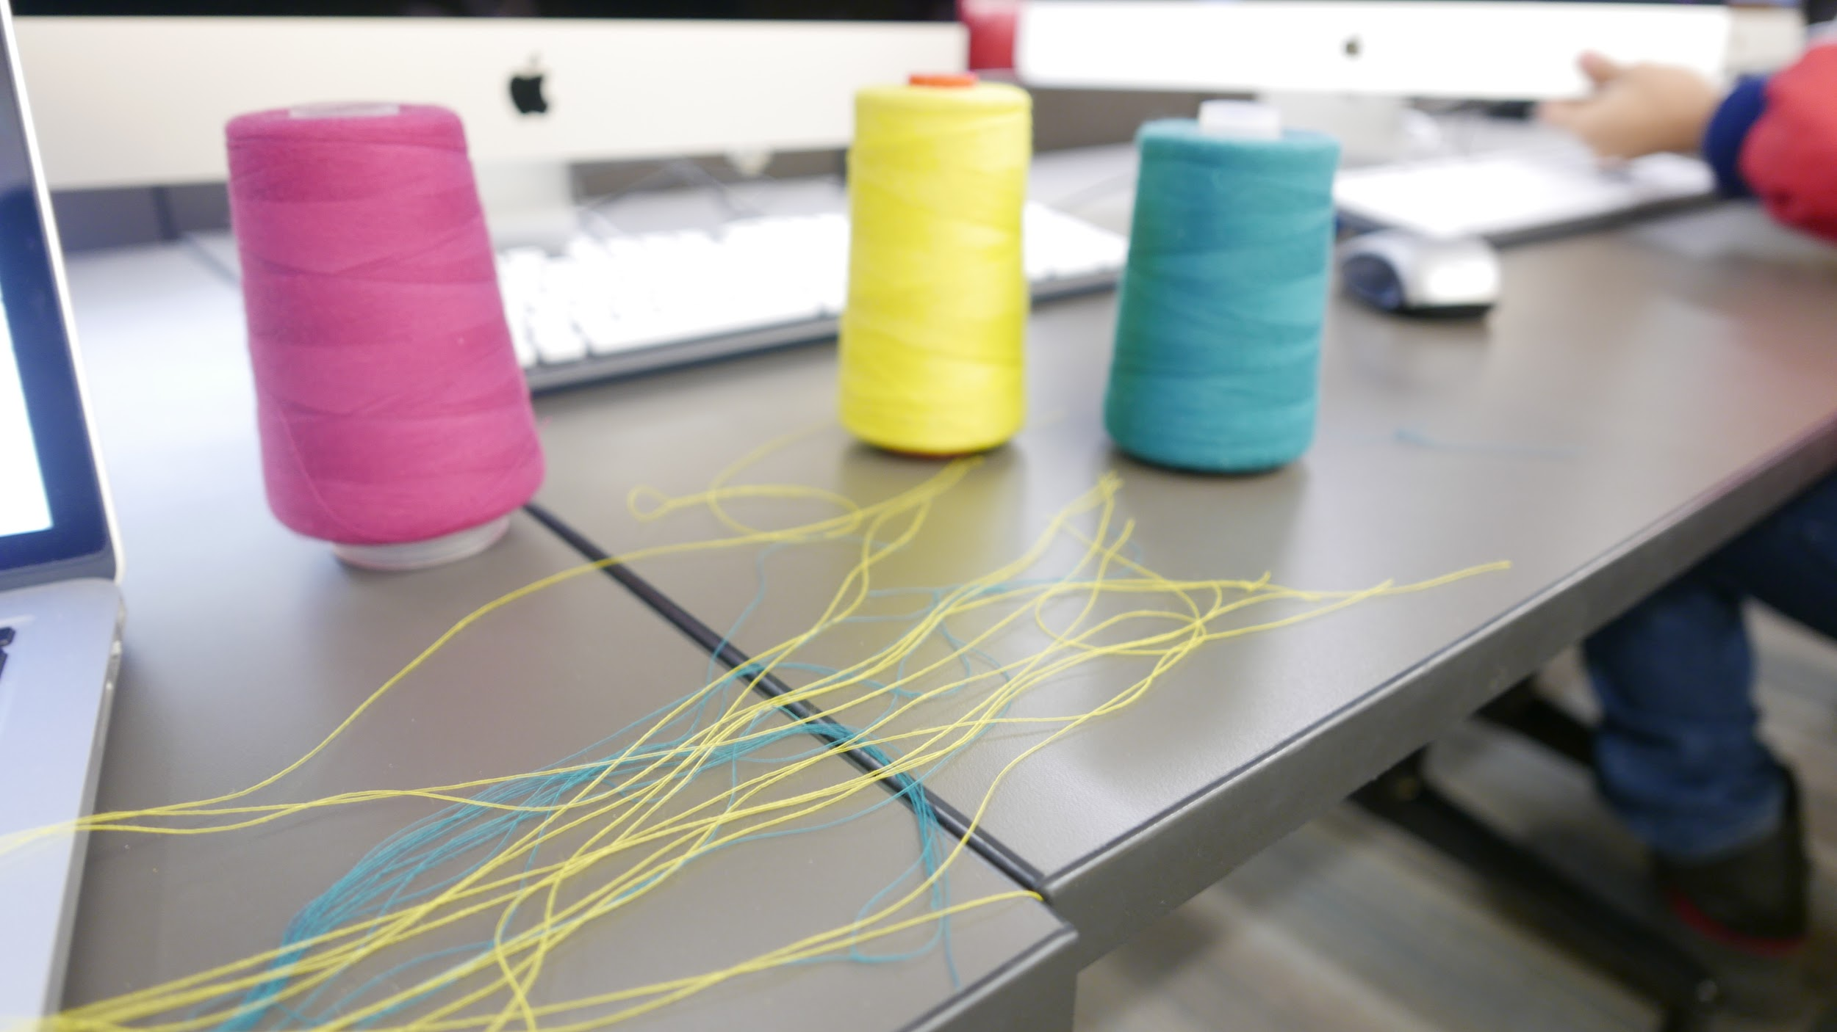

|  |  |  |
| --- | --- | --- |
| MATERIALS (for each participant) | COST | COMMENTS |
| 1 A5 sheet of paper with a [printed grid](https://drive.google.com/open?id=12XGZZ4LX6lqHqOb67LMNAZJwhqZsmO_S) | $ 7 | A5 is equivalent to half letter standard size. 5.8’’ x 8.3’’ or 14.8 cm. x 21 cm. (Price includes paper and print). |
| 1 A5 piece of canvas fabric | $ 10 | Any white or clear woven fabric can be used (no prints or patterns). |
| 1 felt-tip pen | $ 5 | Any pen that is suitable to write on fabric. |
| 1 needle | $ 3 | Regular metal needle that fits the thread thickness. Do not use [‘self-threading’](https://www.maxiaids.com/Media/Thumbs/0006/0006563-colonial-self-threading-needles.jpg) needles. |
| 3 pieces of different colored thread (20’’ each) | $ 5 | Any kind of thread works as long as it matches the size of the needle. |
| 1 or 2 scissors | $ 10 | Not mandatory but it may be required by one of the participants. |

Total budget: $ 40 (U.S. dollars)

The price for each item is enough for a group of 14 people more or less.

**References**

[A] R. Buckner, J. Andrews-Hanna and D. Schacter, “The Brain's Default Network”, Annals of the New York Academy of Sciences, vol. 1124, no. 1, pp. 1-38, 2008.

[B] M. Raichle and A. Snyder, “A default mode of brain function: A brief history of an evolving idea”, NeuroImage, vol. 37, no. 4, pp. 1083- 1090, 2007.

**Links**

[Default stories interactive experience](http://historias.xdefault.cl/en)

[Marcus Raichle interview](https://www.youtube.com/watch?v=_yep_JIupnY)

[Default interactive installation](http://xdefault.cl/)

[Autopilot: the art and science of doing nothing - Andrew Smart](https://www.goodreads.com/book/show/18053732-autopilot)